Components

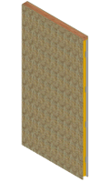
  Wall Panels
  Maximum width 4'-0" (120 cm). Maximum height 16'-0" (480 cm). Panel thicknesses are 3" (7.6cm), 4 1/2" (11.4 cm), and 6 1/2" (16.3 cm). ICS wall panels are built around present construction normal standards. The most common panel is 4'-0" (120 cm) x 8'-0" (240 cm) x 4 1/2" (11.3 cm). Structural components are embedded into each panel providing extra strength and ease of erection. The R-value is approximately R-7 per inch of thickness. Locking devices are embedded at specific intervals providing you with a simple, easy method of securing the panels together. Consequently, field labor is significantly reduced.
  Door and window openings can be pre-engineered into the panels and foamed-in-place, reducing air infiltration and thermal breeches.
  ICS-SIPs reduce construction site waste and material theft.

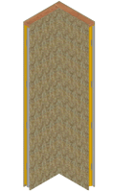
  90° Corner Panels
  The ICS Corner Panel is a one-piece unit. Each leg of the corner has a maximum of 2'-4 1/2" (72 cm) outside dimension and a maximum height of 12'-0" (360 cm). Panel thicknesses are 3" (7.6cm), 4 1/2" (11.4 cm), and 6 1/2" (16.3 cm). The structural capabilities far exceed any traditional building method or other joining methods using two insulated panels butted together to form a corner. The stability of this one-piece construction provides additional strength and eliminates panel racking during erection. Locking devices are embedded at specific intervals providing you with a simple, labor-saving, easy method of securing the panels together. The insulation is injected polyurethane foam injected at a density of 2.5 pounds per cubic foot giving you an insulating factor of approximately R-7 per inch of thickness. In a 4 1/2" (11.4 cm) Corner Panel from ICS you have an insulation value of R-28. The insulation value of the 6 1/2" (16.3 cm) panel is R-42.

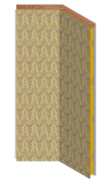
  135° Corner Panels
  The ICS Angle Panel is a one-piece unit. This unique panel allows you to enhance your building architecture while providing structural and insulating capabilities far higher than traditional building methods or other joining methods using insulated panels to form an angle. Locking devices are embedded at specific intervals providing you with a simple, labor-saving, easy method of securing the panels together. The insulation is high-R-value polyurethane foam injected at a density of 2.5 pounds per square inch giving an insulating value of R-7 per inch of thickness. The 4 1/2" (11.3 cm) thick Angle Panel from ICS provides an R-value of 28. The 6 1/2" (16.3 cm) thick panel provides R-42.

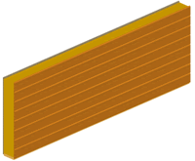
  Roof Panels and Floor Panels
  ICS Roof Panels can be manufactured in two thicknesses, depending on your insulating requirements:
  4 1/2"(11.3 cm) = R28+
  6 1/2" (16.3 cm) = R42+
  Maximum panel length is 16'-0" (480 cm).
  Maximum panel width is 4'-0" (120 cm).
  The insulation is high-R-value polyurethane foam injected at a density of 2.5 pounds per cubic foot.
Insulated Cladding Panels
ICS Insulated Cladding Panels are designed to add insulation to an existing structure over existing walls and roofs, and can be manufactured in nearly any thickness, depending on your insulating requirements. They have a substrate, such as OSB, on one side only. The substrate serves as a nail-base for various shingle or siding applications.
- R-7 per inch of thickness
- Maximum panel length is 16'-0" (480 cm).
- Maximum panel width is 4'-0" (120 cm).
The insulation is high-R-value polyurethane foam injected at a density of 2.5 pounds per cubic foot.

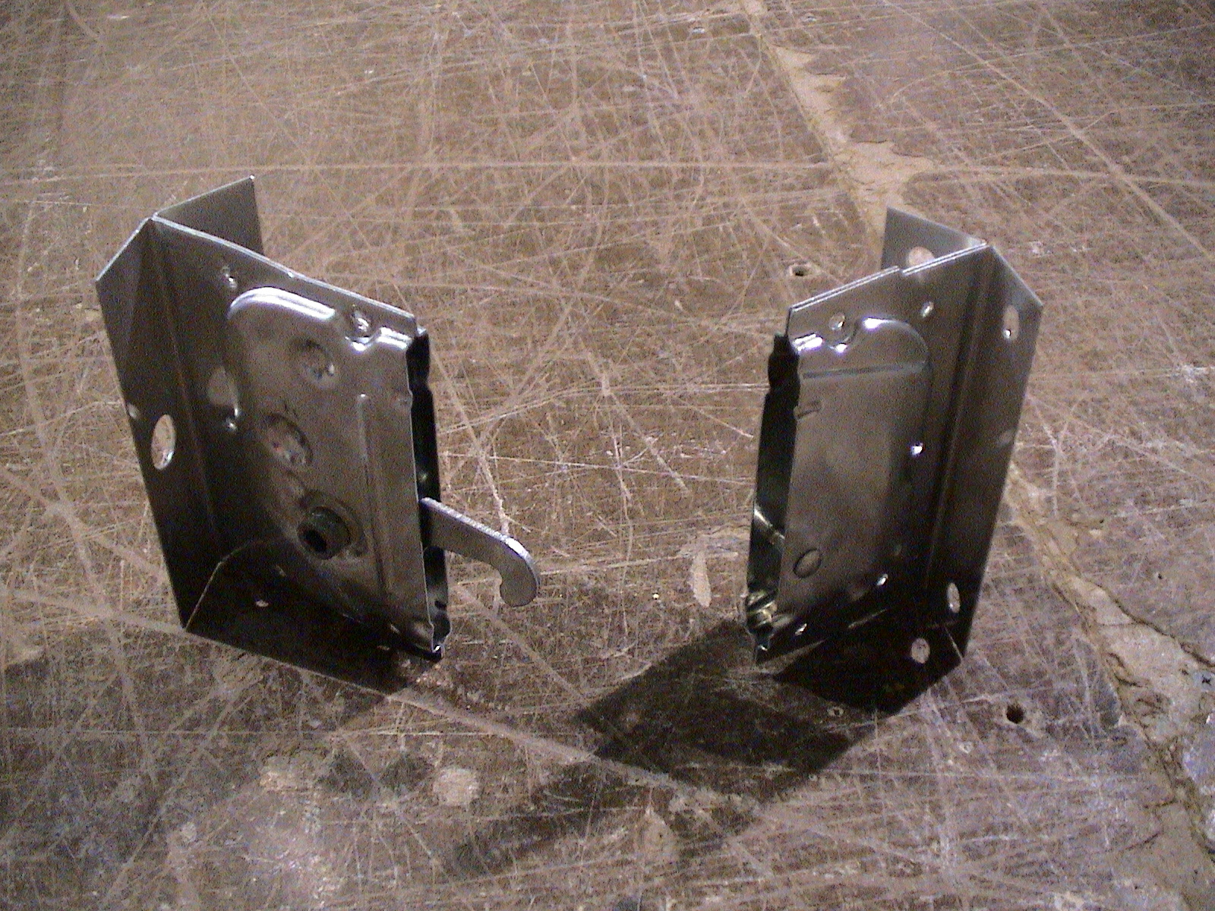
  Cam-Locks
  Concentric steel cam-locking devices are embedded into each panel. These eliminate cutting and nailing panels together. They provide a positive panel seat helping in alignment when joining the panels. The engineered panel fastener offers strength and economy. They save significant field labor compared to spline connection methods.

